The Liberdade Group
(Incorporating Liberdade Community Development Trust and Liberdade Trading Ltd)
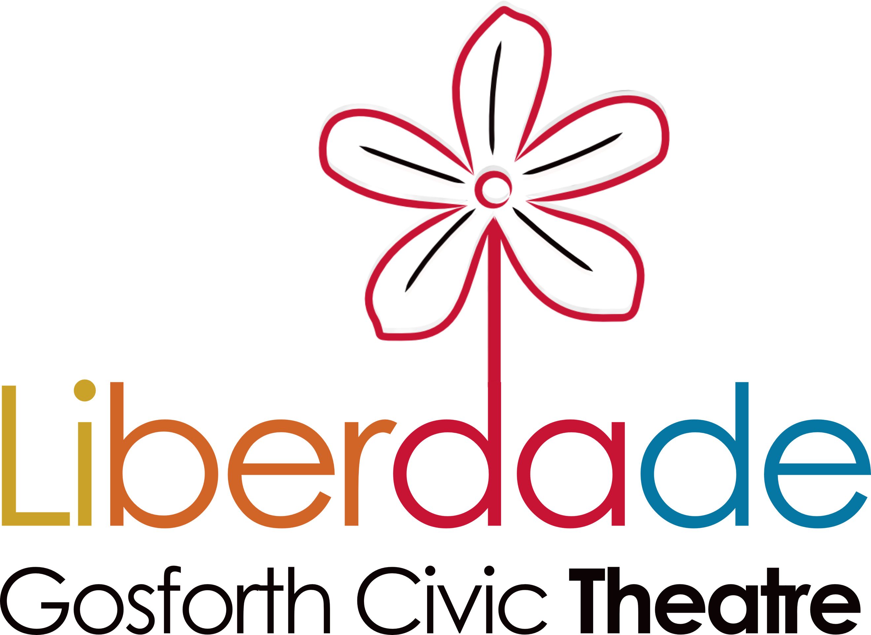
Application Form – Fundraiser

Full name:

When would you be available to start this role?
When would you be available for interview: 19th am 19th pm 20th am 20th pm
We will need to carry out a DBS check on the successful applicant, in line with our safeguarding policy.
Why do you want this job? (What motivates you about this role?) (max 250 words)

For you personally why is our mission important? (max 150 words)

Tell us about an experience of successfully raising funds through bid writing that you are particularly proud of. (max 250 words)

Give us a step by step idea of what your approach would be when formulating a fundraising plan. (max 250 words)

Give us a short compelling description of Liberdade and the difference it makes. (max 250 words)

