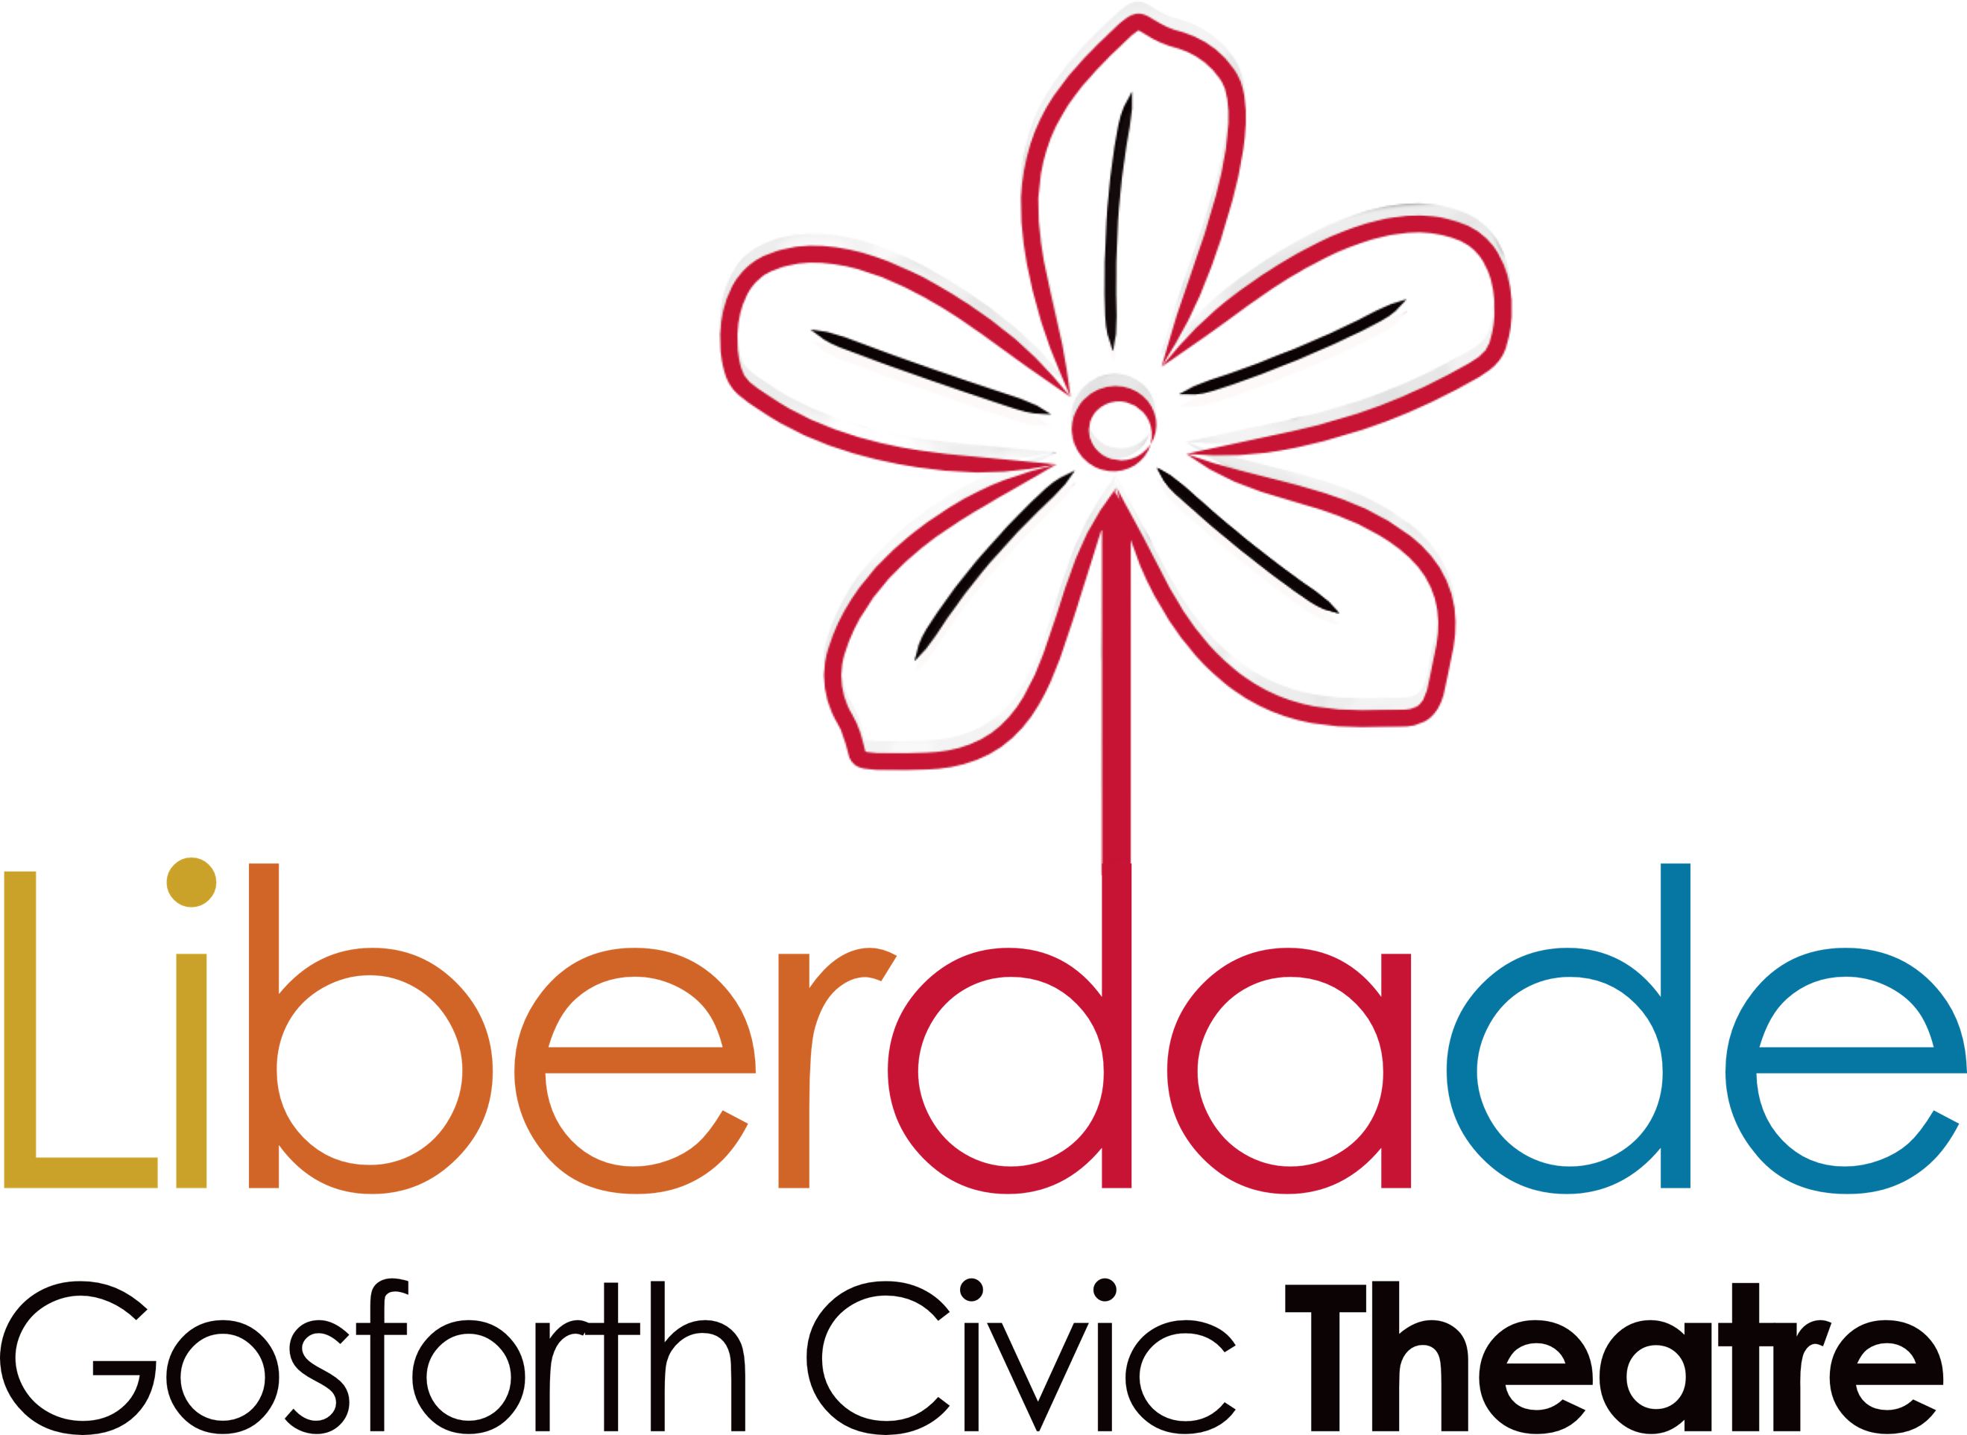
The Liberdade Group
(Incorporating Liberdade Community Development Trust and Liberdade Trading Ltd)

Job Description – Community Engagement Facilitator

Context of the Role
At a pivotal moment in Liberdade’s history, join us to take our social impact to the next level. We have a bold strategy to develop Gosforth Civic Theatre over the next four years and you will have an important part to play in delivering these plans.
We have always used GCT to bring people from the community together. We have learnt that if groups work together creatively then much stronger bonds are formed and the social change increases dramatically. Therefore, we want to create more opportunities where the community and people with learning disabilities can work together collaboratively to develop, produce, and perform creative work. In line with our Arts Development Strategy, we will start small in year one and grow the opportunities in year two and three.
Joining a growing and successful team you will work closely with our CEO, Development Manager and Head of Delivery to implement our new Arts Development Strategy and further our mission. We are seeking a values-driven, organised, and experienced Community Engagement Facilitator.
The Role
This exciting role will have a transformational impact on Gosforth Civic Theatre. As Community Engagement Facilitator, you will work independently and with senior staff to increase community involvement in Liberdade and Gosforth Civic Theatre. You will take the lead on engaging local communities and will be expected to build relationships with community groups, particularly those groups who are currently under-represented at GCT, as identified in our EDI action plan.

You will carry out community consultations, establish and grow links and partnerships with other community organisations, plan and deliver activities for community members, co-ordinate and develop our GCT community forum, support community champions and volunteers, and increase participation in the arts, creativity and culture at GCT.

Terms
Role: Community Engagement Facilitator (title negotiable)
Contract: Permanent
Hours: 24hrs per week (3 days) flexible working
Holiday entitlement: 30 days per year (pro rata) (increasing 1 day per year of service, to a maximum of 35 days pro rata)
Starting: ASAP
Place of Work: Gosforth Civic Theatre and other local venues
Reports to: Development Manager
Salary: £27,000 pro rata per year (Actual £16,200)
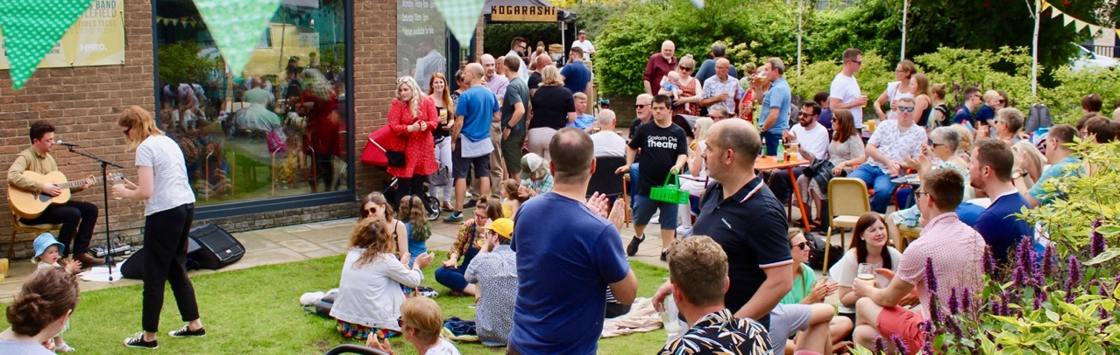
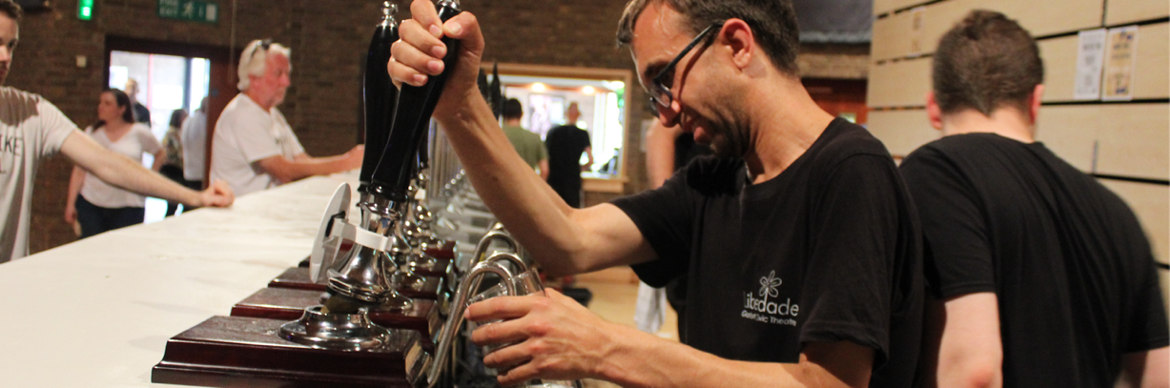

Main Duties and Responsibilities:

As this is a new post there is some scope for you to help shape it and make it your own. However, we expect your main responsibilities will be to:
- Work with the Senior Staff to develop and deliver a community engagement strategy which aligns with our Vision, Theory of Change, Equity, Diversity and Inclusion policy and Arts Development Strategy
- Work with your Line Manager to develop and agree a workplan which will ensure that what you do helps achieve our goals and targets and meets the requirements of those funding your post
- Establish effective working relationships with individuals, groups, and organisations, increasing their involvement in activities at GCT and ensuring our organisation is embedded in the nearby local communities, particularly in Fawdon and West Gosforth Ward
- Work with community-based contacts and networks, to identify community needs and then to plan and deliver projects, programmes and activities to meet those needs
- Promote and increase participation in arts, culture, and creativity by working with Liberdade staff to develop and/or deliver relevant activities and events for local people and groups
- Develop and manage a small team of community champions/mentors who will act as first point of contact for Liberdade/GCT in their own communities
- Support the Senior Team to identify community members who could contribute as Liberdade volunteers and community forum members
- Work closely with Liberdade’s Volunteer Coordinator (this is a new post that is not currently recruited against) to ensure high quality experiences for all volunteers
- Contribute to and/or lead community forum meetings
- Provide and/or contribute to the training of champions/mentors, volunteers, and community forum members.
- Carry out community consultations on an agreed basis ensuring Liberdade has a steady flow of up-to-date community data available
- Produce progress reports as required and contribute to end of grant reports for monitoring and evaluation
- Contribute to larger funding applications and lead on smaller project focused applications as required
- Manage a budget to deliver safe, successful and engaging projects

Key Relationships:
- Reports to – Development Manager
- Responsible for – Artists and practitioners contracted to deliver on projects
- Working in collaboration with – CEO, Head of Delivery, Operations Team and Development Manager

Support you will get from us
- A full induction including information on Liberdade’s history and current work; introductions to all staff that you will work with; training in policies and procedures that are relevant to your role; training in our systems and ways of working as applicable to your role
- A dedicated point of contact who will ensure you are clear on your role and equipped to do it
- The tools and equipment you need to do your job
- The support to do your job safely and in a way which protects you physically and protects your well-being and work/life balance. This includes flexible working options

About Us

Liberdade (Pronounced li-ber-dar-jie) began in 2003 as an apprenticeship scheme with the aim of enabling 8 people with learning disabilities to set up and run their own physical theatre company. We wanted to show how running an organisation could offer people with learning disabilities choice, and the opportunity to shape the world in which they live.

We are now a disability arts charity (No:1163955) with a strong track record of:
- Enabling people with learning disabilities to lead their own organisation
- Running Gosforth Civic Theatre, a 200-seat independent arts venue that brings people together
- Creating high quality physical theatre and film
- Delivering best practice arts and health and wellbeing programmes for people with learning disabilities from across the North East
- Developing partnerships and participating in regional and national network organisations that further our work and enable us to share our practice
www.liberdade.co.uk www.gosforthcivictheatre.co.uk

Over the years we have refined how and why we work in the way we do, this has led to Liberdade’s overarching mission, which is:

To raise everyone’s expectations about what people with learning disabilities can achieve.

Liberdade has a soul, it cares for people and pushes them to excel, it always goes above a beyond and doesn’t know the meaning of can't. People with learning disabilities come to Liberdade to work, to train others, to expel old misconceptions but mostly to belong.
We work by using arts and social enterprise as a tool for change, both within our participants and society as a whole. We use the process of performing and being a member of a company as a mechanism for personal and social development.
Our vision is to create a truly inclusive arts venue that breaks down misconceptions of learning disability and demonstrates that learning disabled individuals are able, skilled, and valuable members of society.

Gosforth Civic Theatre hosts a broad range of theatre, dance, and music performances and activities for our audiences. We run events and activities for the wider community to engage with. It is also the perfect place to host a celebration, special occasion, or social gathering.
In 2019 we held 900 activities and events and attracted 50,000 audience members, participants, and visitors.

Benefits of working for Liberdade / GCT

As a Liberdade / GCT member of staff, you are one of the organisation’s most important assets. We want you to love working for us and to feel supported in maintaining a healthy work-life balance and to develop personally and professionally while you’re with us to give us your best!

Holiday
All staff are entitled to 30 days per year plus bank holidays on a pro rata basis (increasing 1 day per year of service, to a maximum of 35 days)

Time Off in Lieu
While we can’t offer additional pay for overtime, when staff working extra hours is essential we compensate with extra time off, which is intended for resting, recovering and reclaiming personal time lost.

Flexible Working
To support staff in maintaining a healthy work-life balance, we offer flexible working including flexitime, which enables staff to manage their own hours. So, when you need to finish early or have a lie in, you can.

Food and Drink
While working on site at Gosforth Civic Theatre staff are allowed a 50% discounted meal and free hot drinks from our lovely café.

Learning and Development
The quality of Liberdade’s staff is paramount to the organisations success and as our activities and ambitions evolve and develop, so too do our staff. Liberdade positively assesses the skills, knowledge and experience of staff regularly and offers all staff in house training, ad hoc full team training and welcomes requests for other ways that Liberdade might support the learning and development of all staff at all levels.

Competencies: Essential

A minimum of 2 years experience in a community engagement/development role and a demonstrable track record/experience in:

- Designing and delivering excellent community engagement and community development activities
- Delivering cultural projects
- Working with multiple types of groups (e.g., People with learning disabilities, older people, young people, people from the global majority)
- Working in or with communities experiencing disadvantage
- Working in the voluntary and community sector
- Excellent group work and facilitation skills
- Excellent organisational and coordination skills
- IT skills (Microsoft Office, Dropbox, Zoom etc.)
- In addition, you will be expected to demonstrate that you can:
- Recognise and manage risk in line with the organisation’s child protection and safeguarding vulnerable adults’ policies and procedures, particularly when delivering community outreach and engagement activities
- Effectively communicate with colleagues, volunteers, beneficiaries, community members and customers using appropriate language, sensitive judgement, and self-awareness
- Recognise the strengths and capabilities of customers, beneficiaries, community members, staff, and volunteers, supporting them to be the best that they can be
- Be able to adapt communication style to meet differing communication needs
- Embrace our values of equity, diversity, and inclusion, recognising the value everyone brings to Liberdade/GCT and demonstrating inclusion through all your interactions

Competencies: Desirable
- Experience of working with people with learning disabilities and/or autism

